Computer Networks and Data Communication Lab

Secure Multi-Building Campus Network Design Project Report

Submitted To: Sir.Muhammad Farooq
_____________________________________________________________________________________________________________________________________________________________________________________________________________________________________
Student Name: Niha Hawas
______________________________________________________________________________________________________________________________________________________________________________________________________________________________________
Reg. Number: 2312274 ______________________________________________________________________________________________________________________________________________________________________________________________________________________________________

Table of Contents

1. Abstract 2

2. Introduction 2
2.1 Background of the Organization 2
2.2 Importance of Networking 2
2.3 Project Goals and Objectives 3

3. METHODOLOGY 3
3.1 Network Topology & Design Plan 3
3.1.1 Topology 4
3.2 IP Addressing Scheme 4
3.2.1 IP Addressing Scheme Table 4
3.3 Router Configuration 4
3.3.1 Router Configuration Table 5
3.3.2 Router Configuration image 5
3.4 VLAN Configuration 5
3.4.1 VLAN Information Table 6
3.4.2 VLAN configuration image 6
3.5 Access Ports 6
3.5.1 Port configuration image 7
3.6 Server Configuration 7
3.6.1 Server Configuration Table 7

4. RESULTS 7
4.1 Connectivity Verification 7
4.2 Screenshots and Evidence 8
4.2.1 Ping Results 10
4.2.2 Simulation Results 10

5. CONCLUSION 11
5.1 Importance of Network Components 11
5.2 Future Improvements 11
5.3 References 11

Chapter 1: Abstract

This project presents the design and implementation of a secure multi-building campus network for Advanced IT Skills Academy using Cisco Packet Tracer. The network was divided into multiple VLANs including Programming Labs, Networking Labs, Faculty Offices, and Accounts Department. Inter-VLAN routing was implemented to enable communication between departments. RIP and static routing protocols were configured between routers for efficient data transfer. DHCP, DNS, and HTTP servers were deployed to provide automatic IP allocation and web services. Standard ACLs were applied to restrict student labs from accessing the Accounts department while allowing faculty communication. The network was tested successfully using simulation and ping commands.

Chapter 2: Introduction

2.1 Background of the Organization
Advanced IT Skills Academy is a software training institute that provides professional education and practical training in programming, networking, and information technology. The institute contains multiple departments and labs including:
- Programming Labs
- Networking Labs
- Faculty Offices
- Accounts Department
Each department requires secure and efficient communication to support academic and administrative activities. Therefore, a reliable campus network infrastructure is essential for proper resource sharing, internet connectivity, and departmental communication.

2.2 Importance of Networking
A secure and reliable network is essential for educational institutions to ensure seamless communication, resource sharing, and centralized management. Proper network design improves productivity, enhances performance, and provides secure access to services and applications. Networking technologies such as VLANs and routing protocols help organizations manage traffic efficiently while maintaining communication between different departments.4

2.3 Project Goals and Objectives
The primary objectives of this project are:
- To design a secure and scalable campus network
- To implement VLAN segmentation for different departments
- To configure Inter-VLAN Routing between VLANs
- To implement RIP and Static Routing between routers
- To deploy DHCP, DNS, and HTTP servers
- To apply ACLs for controlled network access
- To test and verify network connectivity using simulation

CHAPTER 3: METHODOLOGY

3.1 Network Topology & Design Plan
- A hierarchical network design was implemented using routers, switches, and servers.
- Separate departments were created:
  - Programming Lab
  - Networking Lab
  - Faculty Office
  - Accounts Department
- VLAN segmentation was used for network security and traffic management.
- Centralized servers were deployed for DHCP, DNS, and HTTP services.
- Cisco Packet Tracer was used for simulation
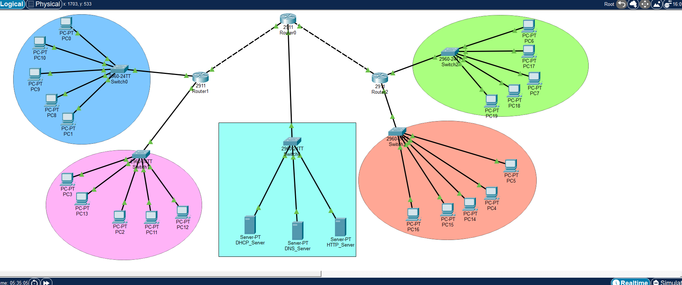

3.1.1 Topology

3.2 IP Addressing Scheme

Department | VLAN ID | Network Address | Default Gateway | Subnet Mask
Programming Lab | 10 | 192.168.10.0/24 | 192.168.10.1 | 255.255.255.0
Networking Lab | 20 | 192.168.20.0/24 | 192.168.20.1 | 255.255.255.0
Faculty Office | 30 | 192.168.30.0/24 | 192.168.30.1 | 255.255.255.0
Accounts Department | 40 | 192.168.40.0/24 | 192.168.40.1 | 255.255.255.0
Servers | 50 | 192.168.50.0/24 | 192.168.50.1 | 255.255.255.0

3.2.1 IP Addressing Scheme Table

3.3 Router Configuration
Router Connection | IP Address | Subnet Mask
Router1 → Router0 | 10.0.0.1 | 255.255.255.252
Router0 → Router1 | 10.0.0.2 | 255.255.255.252
Router0 → Router2 | 10.0.1.1 | 255.255.255.252
Router2 → Router0 | 10.0.1.2 | 255.255.255.252

3.3.1 Router Configuration Table

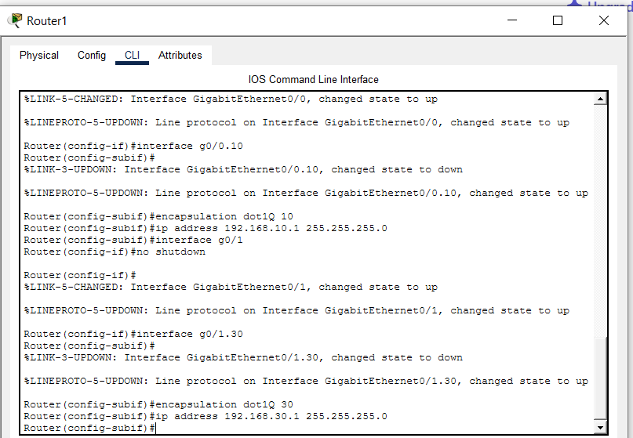

3.3.2 Router Configuration image

3.4 VLAN Configuration
The following VLANs were created:
VLAN ID | VLAN Name | Department
10 | PROGRAMMING | Programming Lab
20 | NETWORKING | Networking Lab
30 | FACULTY | Faculty Office
40 | ACCOUNTS | Accounts Department
50 | SERVERS | Server Network

3.4.1 VLAN Information Table

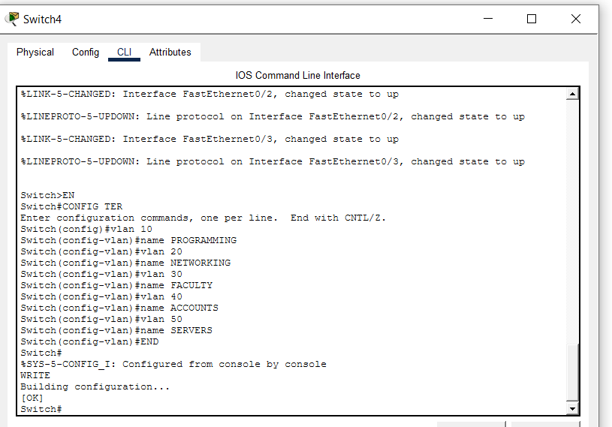

3.4.2 VLAN configuration image

3.5 Access Ports
- PC ports were configured as access ports.
- Each switch was assigned to its required VLAN.
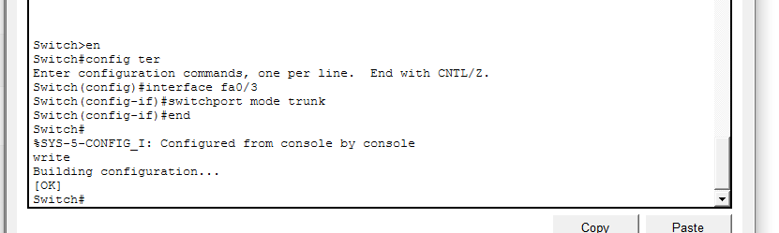

3.5.1 Port configuration image

3.6 Server Configuration

Server Name | IP Address | Function
DHCP Server | 192.168.50.10 | Automatic IP Assignment
DNS Server | 192.168.50.20 | Domain Name Resolution
HTTP Server | 192.168.50.30 | Internal Web Services

3.6.1 Server Configuration Table
DHCP Server
- DHCP server dynamically assigned IP addresses to clients.
DNS Server
- DNS server provided domain name resolution services.
HTTP Server
- HTTP server hosted web services for internal users.

CHAPTER 4: RESULTS

4.1 Connectivity Verification
- Devices successfully communicated within their VLANs.
- Inter-department communication was verified using ping tests.
- ACL restrictions successfully blocked unauthorized access to Accounts department.

4.2 Screenshots and Evidence
- Topology
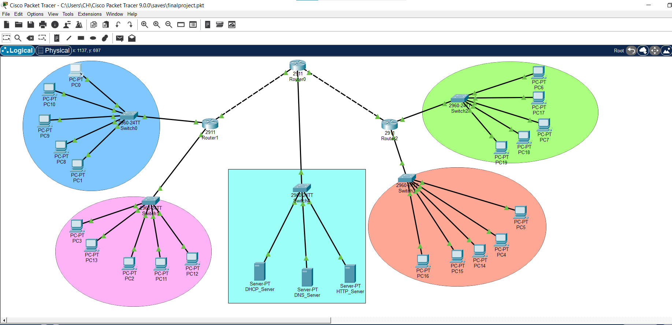
- Ping success
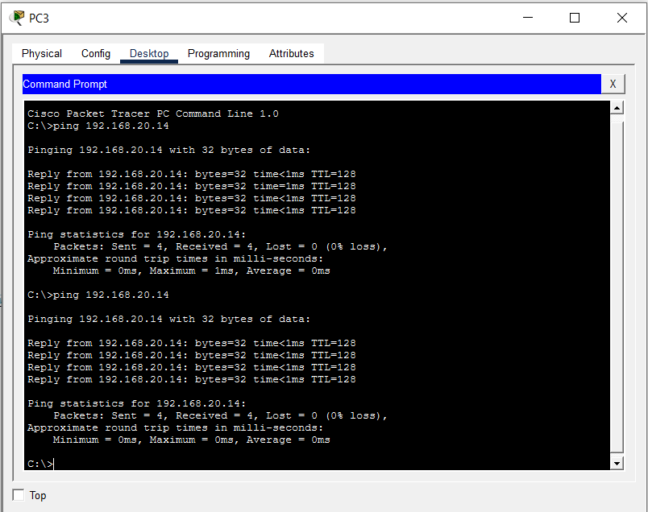
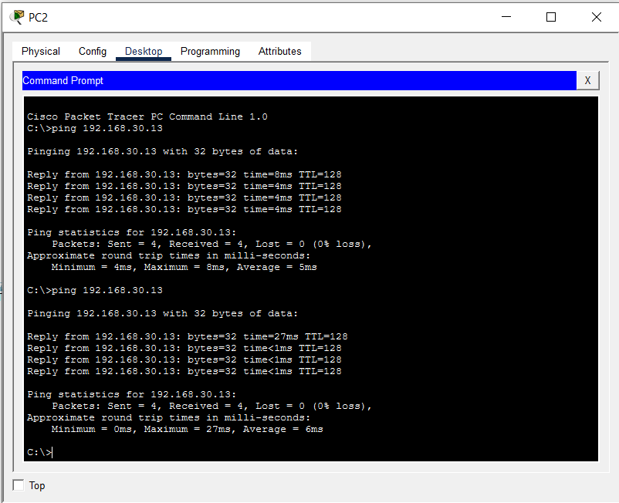

4.2.1 Ping Results
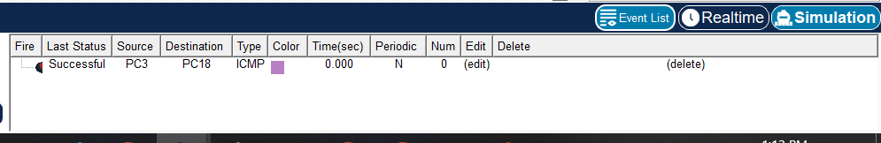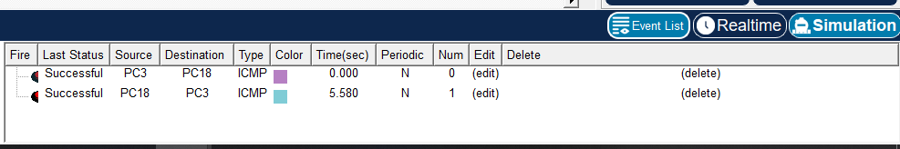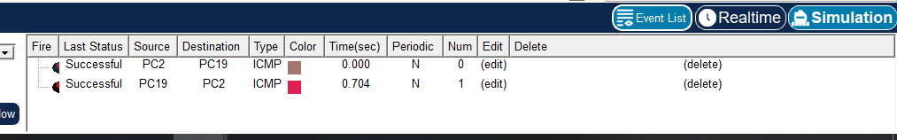

4.2.2 Simulation Results
- RIP routing table
Router | Connected Network | Next Hop | Protocol | Status
Router0 | 192.168.10.0/24 | Directly Connected | RIP | Active
Router0 | 192.168.20.0/24 | 10.0.0.2 | RIP | Active
Router0 | 192.168.30.0/24 | 10.0.0.6 | RIP | Active
Router1 | 192.168.10.0/24 | Directly Connected | RIP | Active
Router1 | 192.168.30.0/24 | 10.0.0.1 | RIP | Active
Router2 | 192.168.20.0/24 | Directly Connected | RIP | Active
Router2 | 192.168.10.0/24 | 10.0.0.5 | RIP | Active

- VLAN configuration
VLAN ID | VLAN Name | Department | IP Network | Devices Connected
10 | SALES | Sales Department | 192.168.10.0/24 | PCs on Switch0
20 | ADMIN | Administration | 192.168.20.0/24 | PCs on Switch1
30 | IT | IT Department | 192.168.30.0/24 | PCs on Switch2
40 | SERVER | Server Room | 192.168.40.0/24 | DHCP, DNS, HTTP Servers

CHAPTER 5: CONCLUSION

5.1 Importance of Network Components
- Routers enabled communication between networks.
- Switches managed VLAN segmentation.
- Servers provided network services.
- ACLs improved security.

5.2 Future Improvements
- Wireless network implementation
- Firewall integration
- Advanced security monitoring
- Expansion for additional departments

5.3 References
- Cisco Networking Academy
https://www.netacad.com/

- Cisco Packet Tracer Official Website
https://www.netacad.com/courses/packet-tracer

- RIP Routing Configuration Guide
https://www.cisco.com/c/en/us/support/docs/ip/routing-information-protocol-rip/13788-3.html

- ACL (Access Control List) Configuration Guide
https://www.cisco.com/c/en/us/support/docs/security/ios-firewall/23602-confaccesslists.html

- VLAN Configuration Tutorial (YouTube)
https://www.youtube.com/watch?v=kCf5sFnTB6U

- Cisco VLAN Configuration Documentation
https://www.cisco.com/c/en/us/support/docs/lan-switching/vlan/10023-3.html

- DHCP Configuration Guide
https://www.cisco.com/c/en/us/support/docs/ip/dynamic-host-configuration-protocol-dhcp/13788-12.html

- DNS Configuration Guide
https://www.cisco.com/c/en/us/support/docs/ip/domain-name-system-dns/13718-40.html

- Routing and Switching Essentials – Cisco Press
https://www.ciscopress.com/store/routing-and-switching-essentials-companion-guide-9781587134289

- Computer Networks by Andrew S. Tanenbaum
https://www.pearson.com/en-us/subject-catalog/p/computer-networks/P200000003146/9780137523214

